Learning Outcome

## Create Styles of web pages using CSS

## 

# Cascaded Style Sheet (CSS)

## Introduction to CSS

CSS stands for Cascading Style Sheets. It is the language for describing the presentation of Web pages, including colours, layout, and fonts, thus making our web pages presentable to the users.

CSS describes how HTML elements are to be displayed on screen, paper, or in other media

It is used to change the style (color, height, width, padding, margin, etc.) of the HTML element. By using CSS, we can design a very good user interface for your website or web application.

Styling your web page to make it look appealing is also an essential element of web designing and development. CSS helps in giving styles for describing the presentation of the markup-based documents.

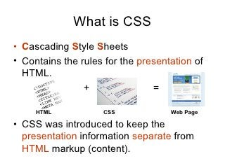

Image 1: CSS

Reference: <https://www.slideshare.net/webdevninja/introduction-to-css-13603389>

**World Wide Web Consortium(W3C)**

CSS is developed, updated, and maintained by a faction of people of the W3C, and the group is named "CSS Working Group". This group produces documents called specifications. When these specifications in the form of documents are released and approved by the developers' community, they are set officially so that other users can use it as a standard mechanism of using CSS.

### History of CSS​

CSS was first proposed by **Hakon Wium** Lie on October 10, 1994. At the time, Lie was working with Tim Berners-Lee (father of Html) at CERN. The European Organization for Nuclear Research is known as CERN. Hakon wium lie is known as father of css.​

CSS was proposed in 1994 as a web styling language, to solve some of the problems of Html 4. ​There were other styling languages proposed at this time, such as Style Sheets for Html and JSSS but CSS won.



Image 2: Founder of CSS

Reference: : <https://www.shecodes.io/workshops/shecodes-online-workshop-46-0/projects/197698>

**Include properties in CSS2**​

CSS level 2 specification was developed by the W3C and published as a recommendation in May 1998. CSS 2 includes a number of new capabilities like below;​

* absolute​
* relative​
* fixed​
* positioning​
* z-index​
* concept of media type​
* bidirectional text​
* new font properties such as shadows.​

CSS3 was started in 1998 but it has never been completed. Some parts are still being developed and some components work on some browsers. It published in June 1999. CSS 3 is divided into several separate documents called "modules". Each module adds new capabilities or extends features defined in CSS 2.​

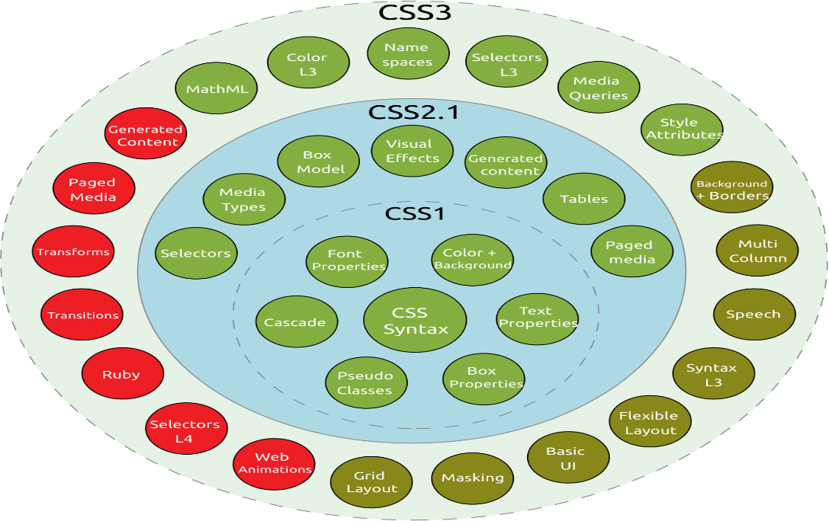

Image 3: History of CSS

Reference: <https://www.shecodes.io/workshops/shecodes-online-workshop-46-0/projects/197698>

### Why CSS?

**CSS saves time:**

You can write CSS once and reuse same sheet in multiple HTML pages.

**Easy Maintenance:**

To make a global change simply change the style, and all elements in all the webpages will be updated automatically.

**Search Engines:**

CSS is considered as clean coding technique, which means search engines won’t have to struggle to “read” its content.

**Superior styles to HTML:**

CSS has a much wider array of attributes than HTML, so you can give a far better look to your HTML page in comparison to HTML attributes.

**Offline Browsing:**

CSS can store web applications locally with the help of offline cache. Using of this we can view offline websites.

## Limitations of CSS

**Confusion due to many CSS Versions:**

Beginners are more vulnerable to this issue. They might get confused while opting to learn CSS as there are many levels of CSS such as CSS2, CSS3, etc.

**Cross-Browser Issues:**

Different browsers work differently. So, you have to check that changes implemented in the website via CSS codes are reflected properly among all the browsers.

**Security Issues:**

Security is important in today’s world driven by technology and data. One of the major disadvantages of CSS is that it has limited security.

**Extra Work for Developers:**

Design services are required to consider and test all CSS codes across different browsers for compatibility. Due to developers testing compatibility for different browsers, their workload increases.

## Advantages of CSS

**CSS saves time**

Once you write a CSS code you can use it in more than one HTML page. User can define a style for each HTML element and it can apply as many web pages. By doing this we save a lot of time.

**Pages load faster**

You don't need to write HTML tag attributes every time if you are using CSS. Just write a CSS Rule of a tag and apply it to every web pages. By doing this, the download time of your website will be greatly reduced.

Maintenance of a website becomes very easy using Easy maintenance −CSS. If you want to change the style of your website completely, then you have to change the simple style code, all the other page elements will be changed automatically.

**Superior styles to HTML**

CSS has a lot more detailed features than HTML, allowing you to give your HTML page a much better look than HTML features.

**Multiple Device Compatibility**

Style sheets allow the material to be optimized for more than one type of device. Using the same HTML document, different versions of a website can be presented for handheld devices such as PDAs and cell phones or for printing.

**Global web standards**

Now recommended to use CSS as required by HTML attributes. So, it is a good idea to start using CSS in all HTML pages to make them compatible with future browsers.

**Offline Browsing**

On using CSS, we can view offline websites. The cache is also very helpful in making a website load faster and ensures better performance of the website.

**Platform Independence**

CSS Script provides consistent platform independence and also supports every latest Web Browser.

## CSS Syntax

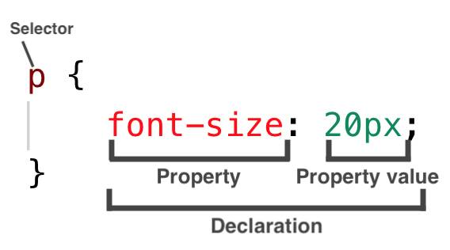

Image 4: CSS Syntax

**Selector**: selects the element you want to target​

**Keys**: properties(attributes) like color, font-size, background, width, height, etc​

**Value**: values associated with these properties​

There are few basic selectors like tags, id’s, and classes​All forms this key-value pair​.

### CSS Comments

Comments don’t render on the browser​

* Helps to understand our code better and makes it readable.​
* Helps to debug our code​

Comments are used to explain the code, and may help when you edit the source code at a later date.​

Comments are ignored by browsers.​

​**Two ways to comment:​**

**Single line**​

/*<h6> This represents the most/ least important line of the doc. </h6>*/​

​

**Multiple lines:**​​

/*​

         h1​

     {​

     color: red;​

     text-align: center;​

      } ​

*/​

### White Spaces in CSS

White spaces are special characters that can be an actual space, tab, or newline (carriage return). These whitespaces are used to construct your stylesheets extra readable. Like that of HTML, the browser usually ignores almost all of the whitespaces within your CSS code; and is meant to make the code human-readable.

## Three ways to integrate CSS

There are three ways of inserting a style sheet in any Html documents.

* Inline style sheet​
* Internal style sheet​ (Embedded)
* External style sheet​

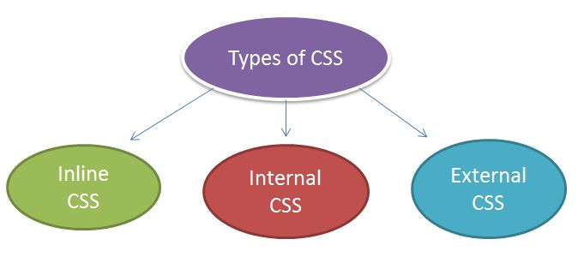

Image 5: Types of CSS

Reference: <https://www.bitdegree.org/learn/inline-css>​

**Inline Styles:**

* Inline styles are placed within an HTML element in the code.
* When you use inline style, your styling will only affect the element you selected.
* Inline styles do not have selectors because its written inside the html element.

Example:

<p style="color: red; margin-left:20px">This is a paragraph. </p>​

**Internal Styles:**

* are placed in head head section of the web page you are writing via style tag <style type=”text/css></style>.
* The styles you have written will only be used for the web page you used it in.
* Internal Styles are also called “Embedded styles”

Example:

<style>

hr {color:red;}

p {margin-left:20px;}

</style>

**External Styles:**

External Styles can be reused to apply on more than one page by only linking the style sheet to the web page.

Write your CSS codes via any of the code editors and then save it as a .css file. then link the style sheet to the HTML page by adding this code in the head section:

Example:

<head>​

<link rel="stylesheet" type="text/css" href="name of the Css file">​

</head>​

            p{​color: red; }​      //.css file​

## Merits and demerits of - external Style Sheets, Embedded Style Sheets

**Embedded Style Sheets**

**Merits**

* No need to upload multiple files as the CSS code is added to the same HTML file corresponding to the web page.
* Class and ID selectors can be used.

**Demerits**

* Adding CSS code to the HTML file results in increasing the page size and therefore, reducing the loading speed.
* Using it for multiple web pages is ineffective as it is required to add the same CSS rules for every web page

**External Style Sheets**

**Merits**

* A single external CSS file can be used for styling several web pages.
* HTML files leveraging external CSS have a cleaner structure and are smaller in size.

**Demerits**

* Linking to or uploading several external CSS files might decrease a website’s download speed and affect its performance.
* Web pages requiring the external CSS file might not be rendered accurately until the same is fully loaded.

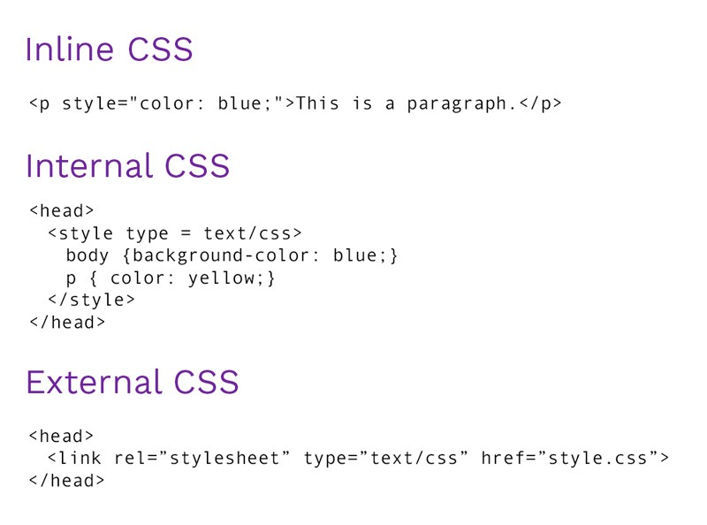

Image 6: Types of CSS

References

1. <https://www.w3schools.in/css3/introduction-to-css/>